Worksheet


Items highlighted in yellow are tasks for you to complete
Items in Blue italics are help tips

Interactive Power Point

Topic: Creating an interactive slide show

You are going to create a Power Point Open the great images graphics file

You must use hyperlinks, animation and action buttons

Student link
Create a front cover
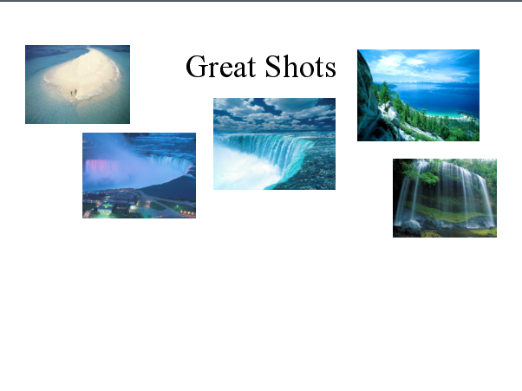
Add hyperlinks to each small picture to take you to that slide.

Now add three buttons for each slide

Previous Slide Home Next Slide
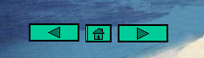

Put these on the MASTER SLIDE

Put a background on the master slide

Make all pictures animate

Put transitions into each slide

Self Evaluation

Tick the appropriate box: No Undecided Yes
I found this task interesting
I have worked hard on this task
I have understood the task requirements
I enjoyed working on the task
I had enough time to complete the task
I had all the skills required to complete the task
I am happy with my finished product
I found it easy to find the information I required

My favourite part of the task was:

The most difficult part of the task was:

The easiest part of the task was:

The most interesting part of the task was:

I could improve my final product by:
Student Name:________________________________________

Evaluation (by Teacher)
Your goal is to achieve the highest possible score for each of the lesson tasks described in the sheet. Read the requirements for achieving each level of performance and constantly evaluate your progress so your portfolio will reflect excellence in process, research, organization, writing, design, and collaboration.

Lesson Number______

Not Demonstrated  1 | Satisfactory  2 | High  3 | Very High  4 | Score
The student has not submitted work for this project | The student displays organisational skills, and contributes to the achievement of set goals for a specific task. | The student displays effective organisational skills, and demonstrates some initiative when working towards the achievement of set goals. | The student displays high motivation, independence, co-operation and responsibility when working towards the achievement of set goals. | GUIDE
Uses very few resources, most of which are unrelated to the goals of the project. Little indication of effective skills or technique, poor research methods.  Late presentation of task. | Uses only a few sources of information that are used effectively. Reflects a limited amount of effort to find appropriate resources and create an effective and interesting result | Several sources of information are used which relate to the process of creating an effective result. References come from a variety of sources. The use of both text and graphics is incorporated appropriately. | Uses many types of resource materials including text, graphics, photos, and other documents. Excellent choice of materials that provides excellent information appropriate to the task.

